1923670

Refiloe Raselane

1. Creating a standard partition

Step1. Displaying mounted disks

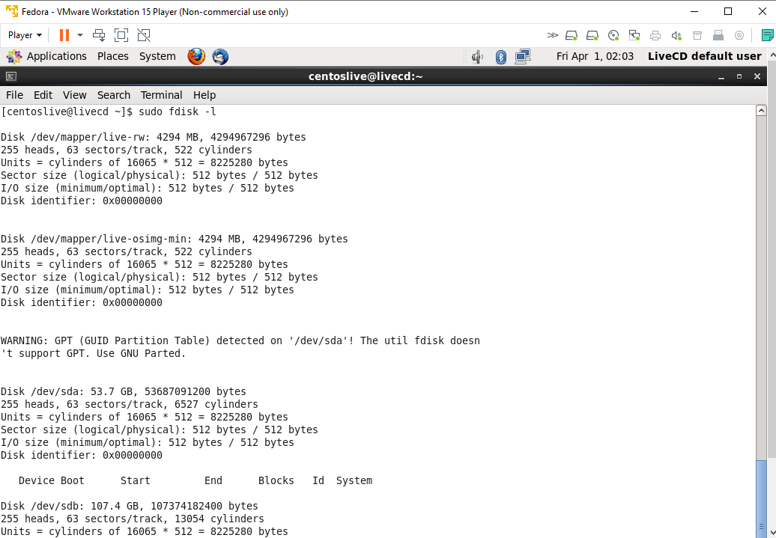

Step2. Creating a partition of size 20GB on /dev/sda.

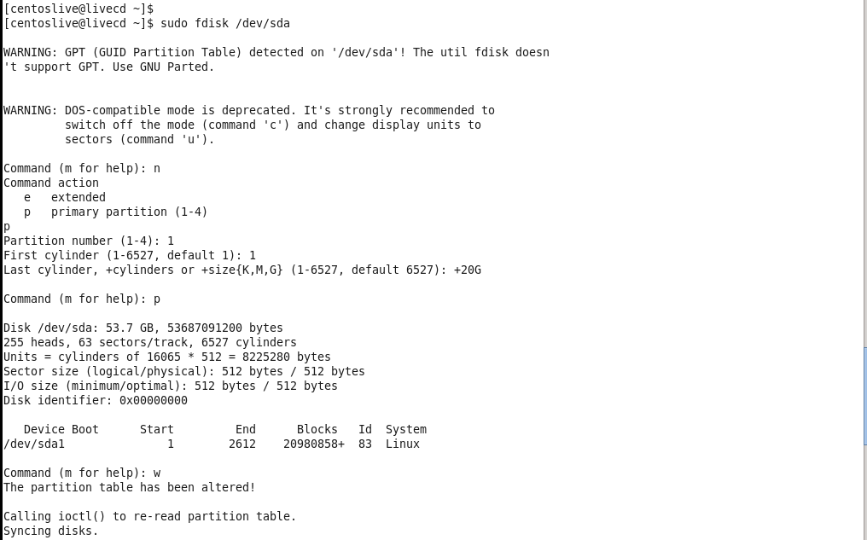

Step3. Creating a partition of size 20GB on /dev/sdb.

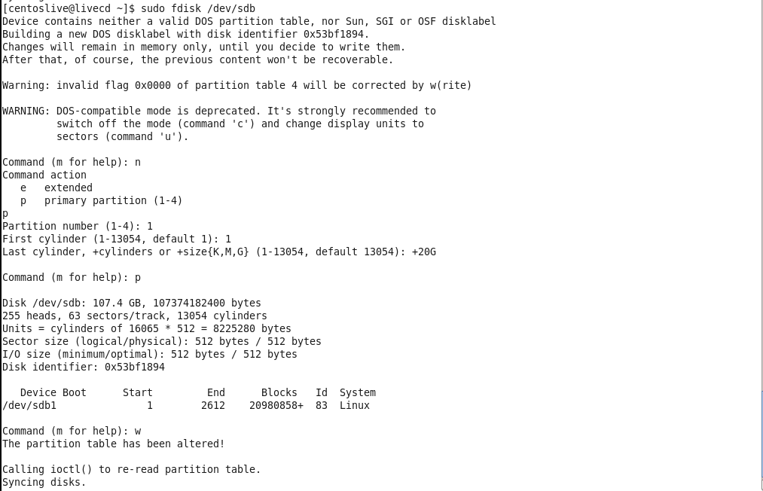

1. Creating physical volumes

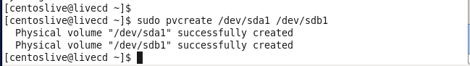

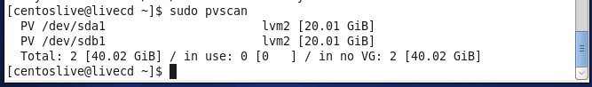

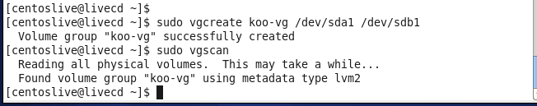

1. Creating Logical Volumes

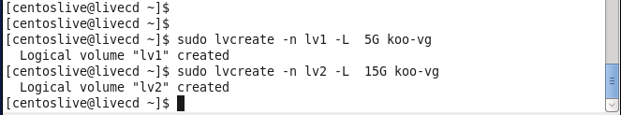

1. Creating File Systems

Step1. Creating file system for the logical volume “lv1”.

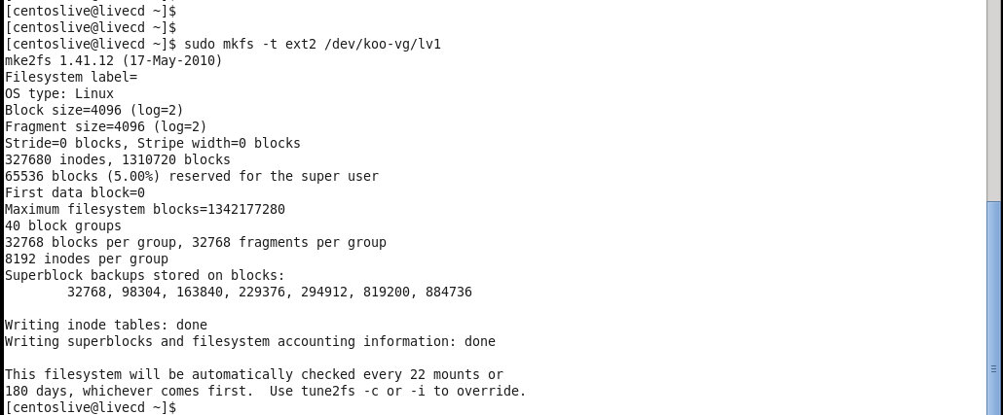

Step2. Creating file system for the logical volume “lv2”.

